Availability of Switches / Buttons and etc.
ACC On/OFF | ACC Switch 3in1 | ACC Reverse button | ACC 3 gear /way Switch | Turn Signal Relay for LED CF-13 / 12V | ANL MINI fuse holder + Fuse | DC Fuse ANL MINI
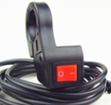 | 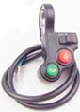 | 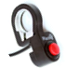 | 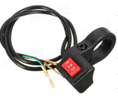 | 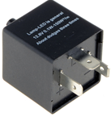 | 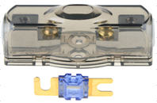  (20/40/60/80A  /100/150/200A | 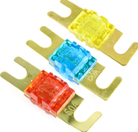  (20A/40A/60A  /80A  /100/150/200A
10 € netto | 10 € netto | 10 € netto | 10 € netto | 10 € netto | 6 € netto | 2,5 € netto
From stock | From stock | From stock | From stock | From stock | From stock | From stock
Availability of speed throttles
Speed throttle with ignition key | Half Speed throttle with ignition key and Voltage indicator | Ignition with Voltage indicator G-P229 | Thumb speed throttle with LED ignition key and button | Thumb speed throttle (3 wires) | Foot spee throttle (with internal foot switch) | JOYSTICK for E-BOAT
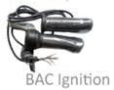 | 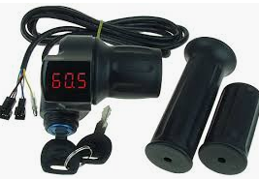 | 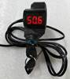 | 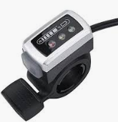 | 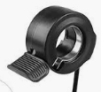 | 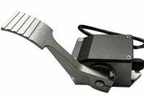 | 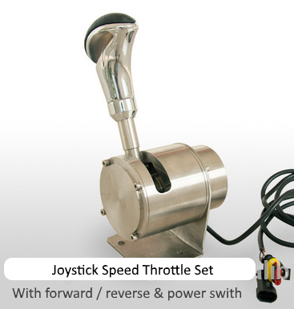
21 € netto | 21 € netto | 21 € netto | 15 € netto | 15 € netto | 65 € netto | 299 € netto
From stock | From stock | From stock | From stock | From stock | From stock | From stock
Accesories for the motor
Pulley 24T  (for belt 8M) or Sprocket 15T | Opposite side  Big pulley | Timing  Belts | Basic Display for vehicles 48-100V | Motor mounting bracket  HPM-3K 5K 10kW | Liquid cooling cover  HPM-3K 5K 10kW | Cooling pump  12Vdc  3,5-8 L/min
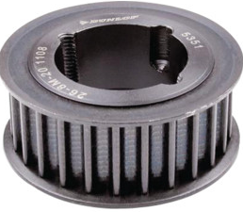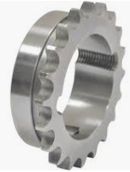 | 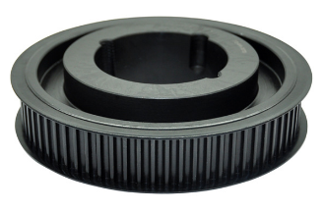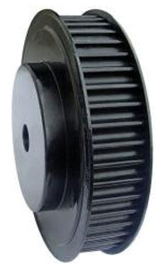 | 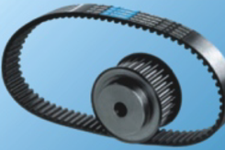 | 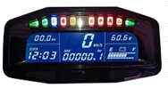 | 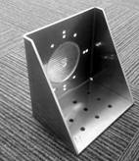 | 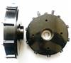 | 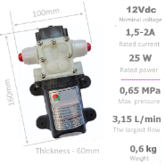
25 € netto | On request | On request | 125 € netto | 65 € netto | 56 € netto | 75 € netto
From stock | 1-3 weeks | 1-3 weeks | From stock | From stock | From stock | From stock
RPM of Propeller under water should be between ~ 1600-2500 RPM, in order to reduce motor RPM and increase the torque we suggest to use reducing gearbox. By default we & our customers do it using the teeth belt and pulleys. (ration 2:1 or 1,8 : 1 )

Availability of other parts
Hydraulic brake levers with micro contact for motorcycle | Sensors for hyraulic brakes for Ebike (2pcs) | Sensors for hyraulic brakes for Ebike (2pcs) with 3pin connec. | Brake levers with micro contact for Ebike
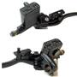 | 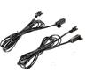 | 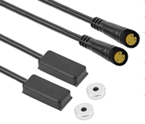 | 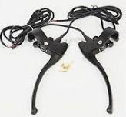
35 € netto | 30 € netto | 30 € netto | 25 € netto
From stock | From stock | From stock | From stock

Availability of DC contactors
Emergency Switch 250A | DC contactor 48V / 200A | DC contactor 72V / 200A | Up to 120Vdc /100A with short circuit and overload protection | DC contactor 12V /400A | DC contactor 12V /600A
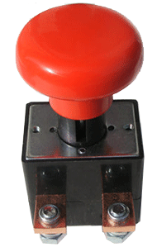 | 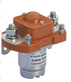 |  | 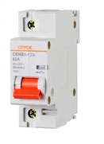
35 € netto | 35 € netto | 35 € netto | 35 € netto | 65 € netto | 95 € netto
From stock | From stock | From stock | From stock | From stock | From stock

Availability of small electric parts
ANL MEGA  fuse holer | ANL 80Vdc FUSE  100/150/200/250A  300/400/500A | DC FUSE holer with fuse | Fork Handle For battery plug 175/350A | Battery  power plug  350A | Battery  power plug 175A | Battery power plug 50A
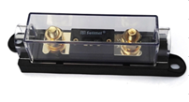 | 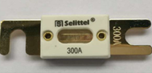 | 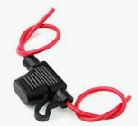 | 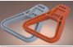 | 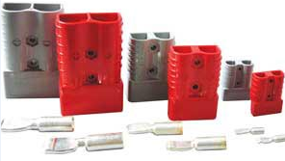
3.5 € netto | 6 € netto | 30 € netto | 12 € netto | 40 € netto | 18 € netto | 5 € netto
From stock | From stock | From stock | From stock | From stock | From stock | From stock

